Appendix A

Broderick Park Arts Commision Potential Public Art Locations
There are two general areas of consideration:
- Within the Park
  - The Great Lawn
  - Bus Drop off Circle
  - Between Amphitheatre and Plaza
  - In the “Forest”

- The Concrete walls Underneath the 190 Overpass on Robert Rich Way
  - South Side
  - North Side

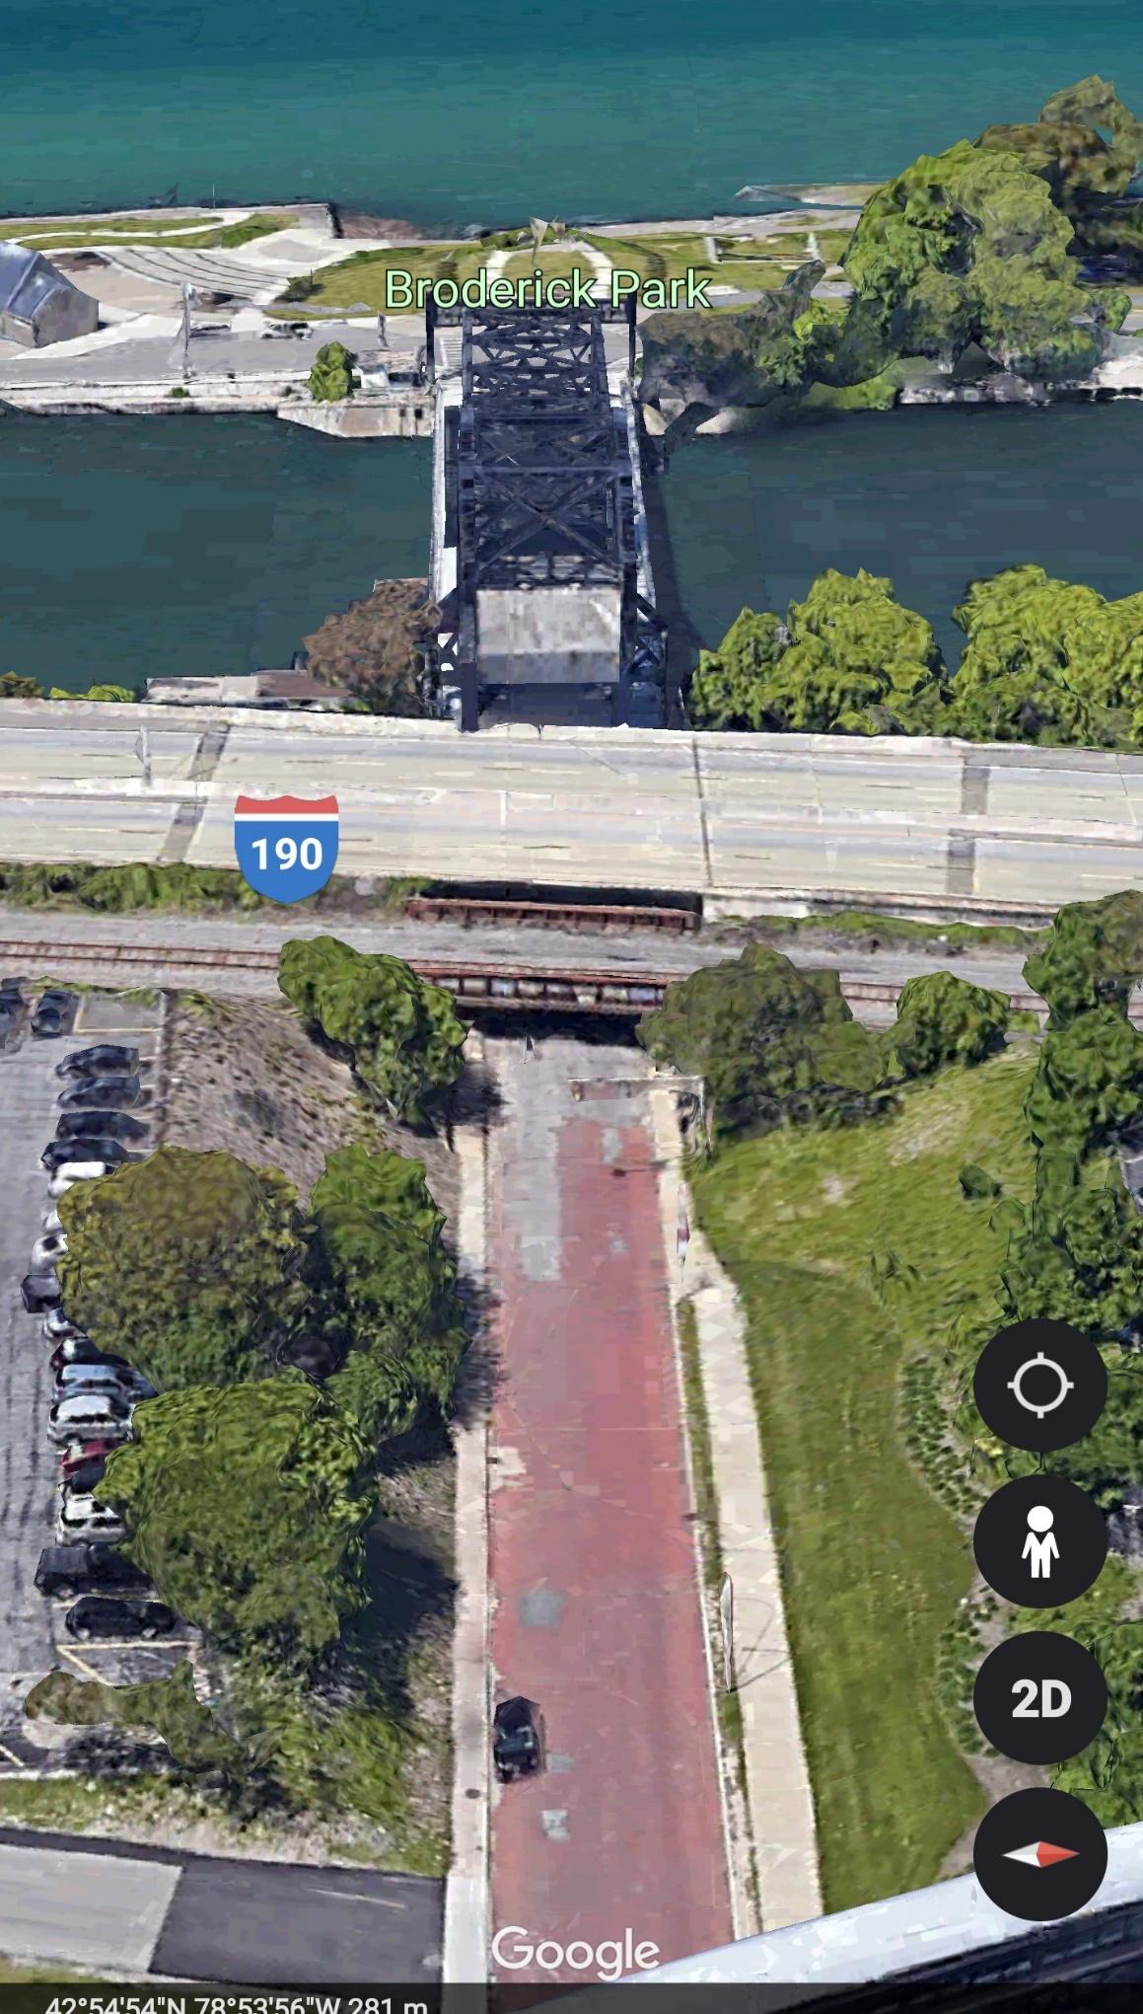
Art in the Park

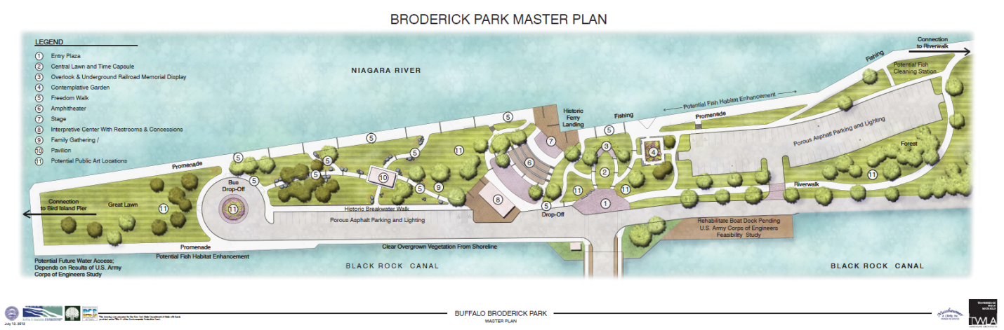
Original Master Plan

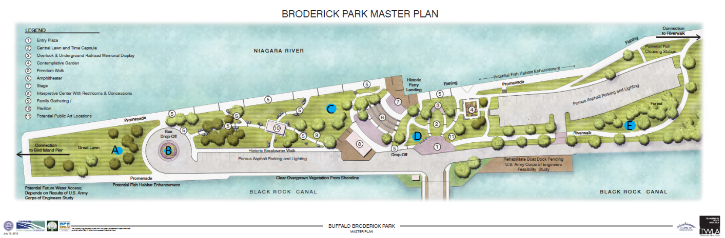
Master Plan with Proposed Public Art Locations

- Within the Park
- The Great Lawn
- Bus Drop Off Circle
- Between Amphitheatre and Plaza
- In the “Forest”
A. The Great Lawn Approximately 210’ X 75’
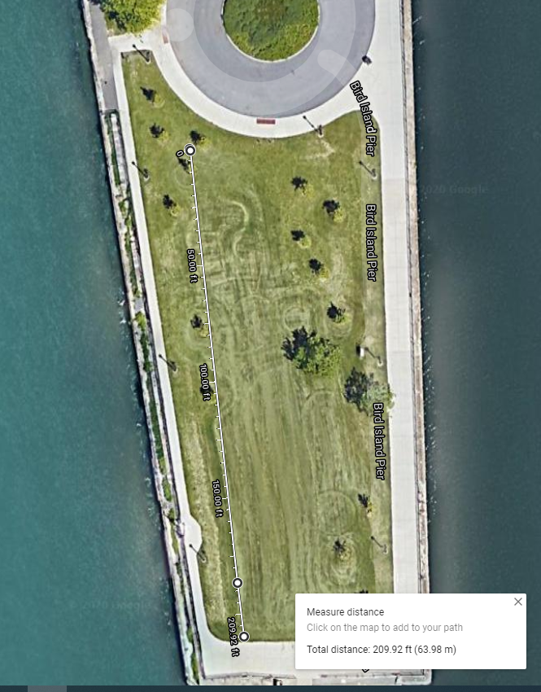

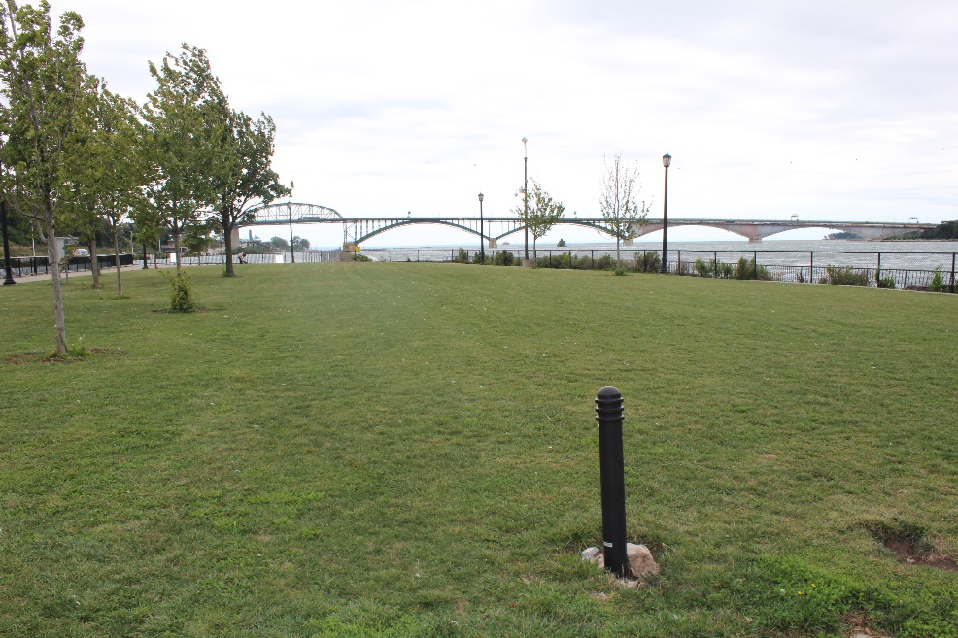

B. Bus Drop off Circle
Circle is 40’ in Diameter and Currently Planted with Woody Shrubs
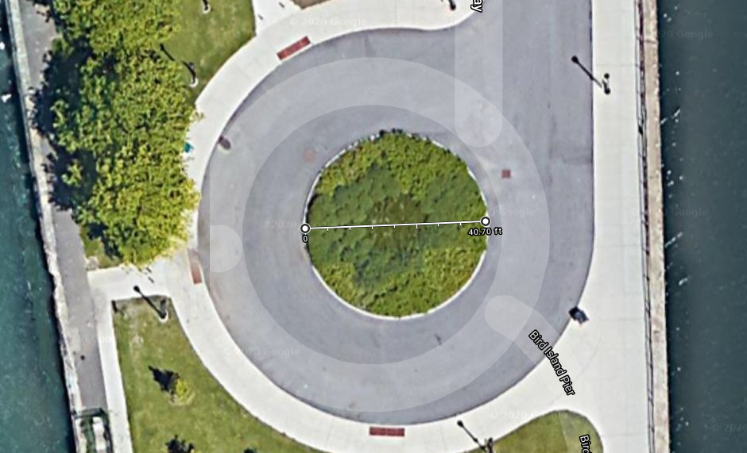
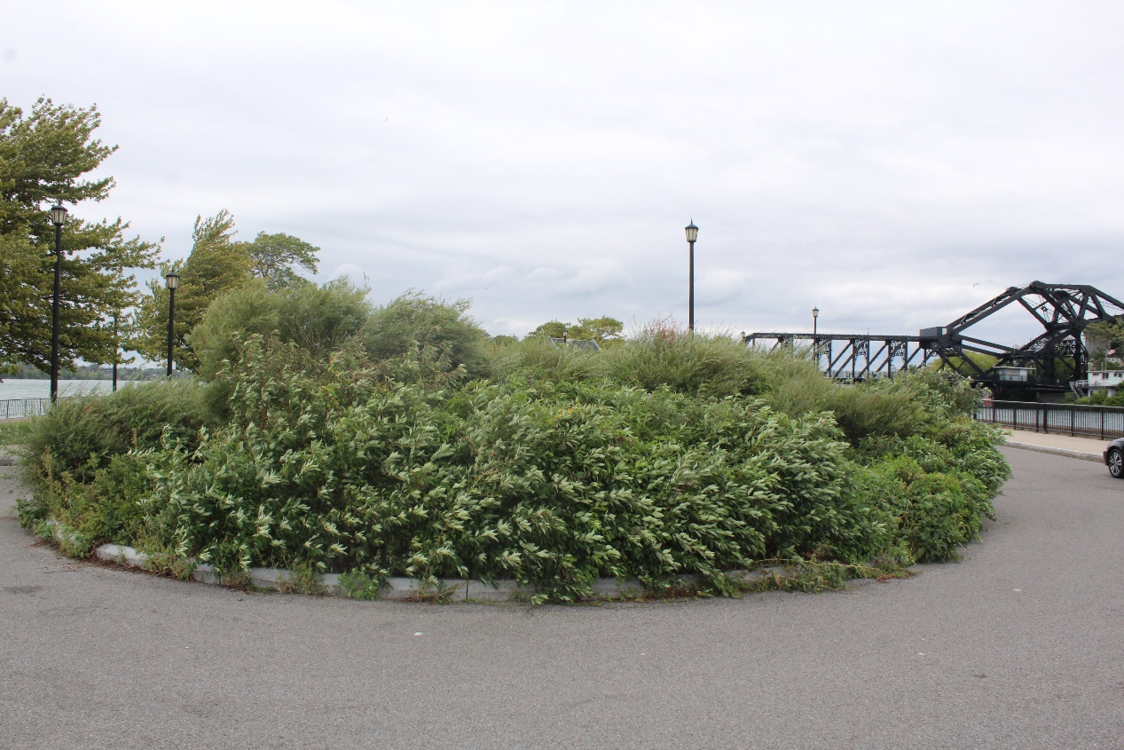

- Between Amphitheatre and Plaza 43’X 50 (Narrows to 36’ near river)
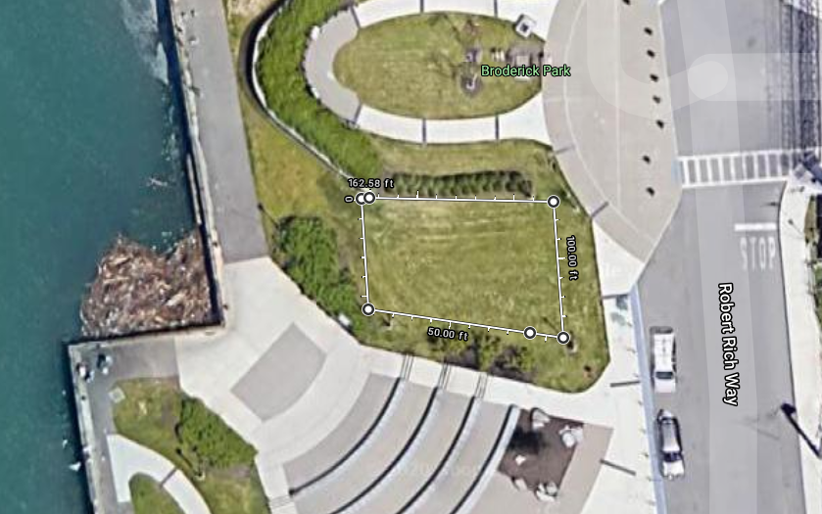
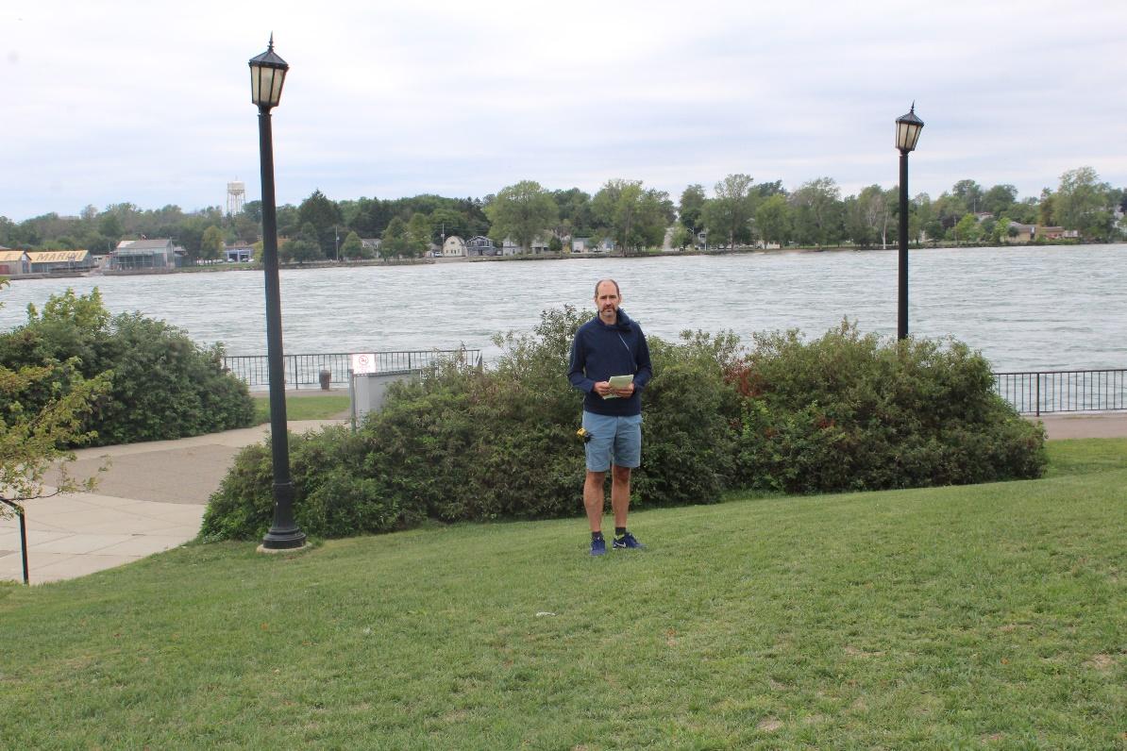

Between Amphitheatre and Plaza (Continued)
View from road entering the park.
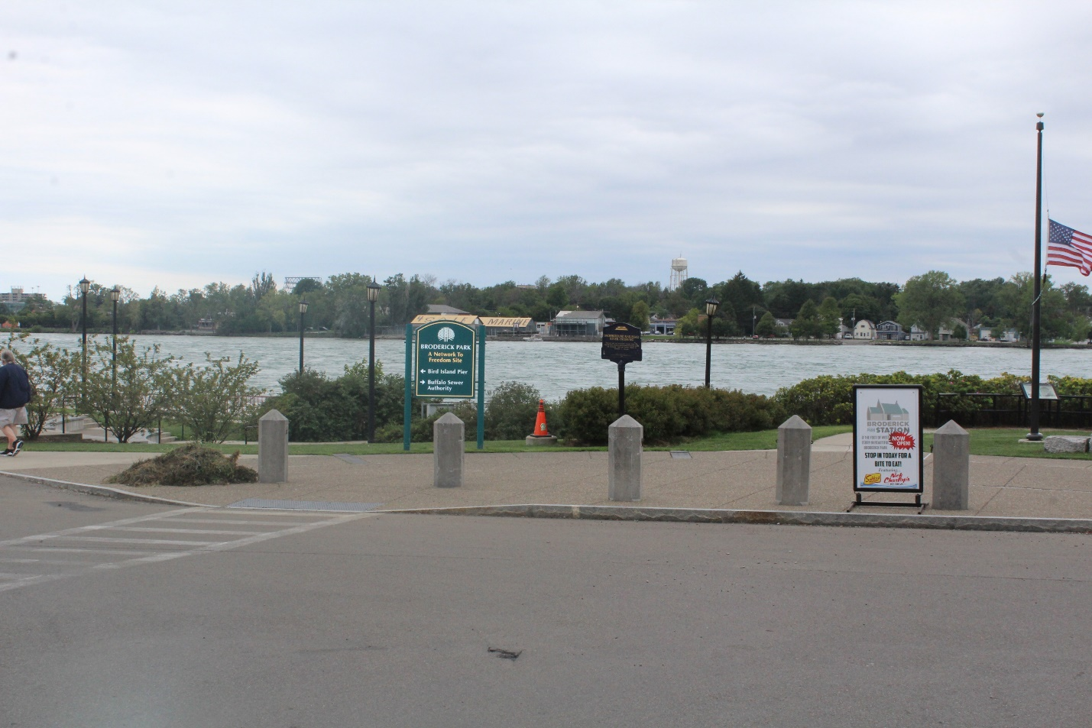
D In The Forest
Approximately 320 Feet long by 20-50’ Wide
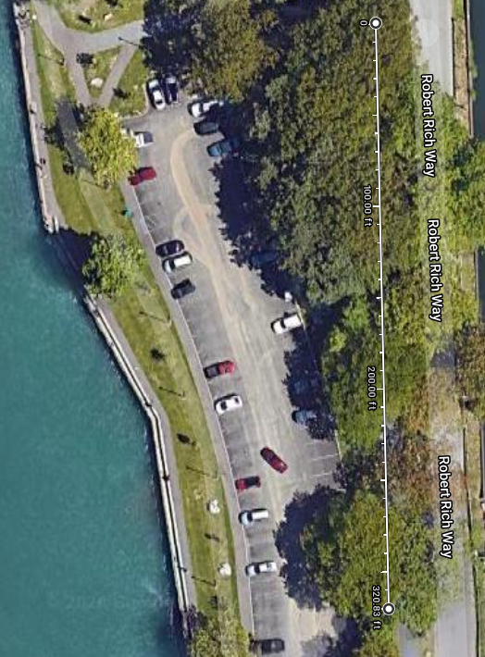

- Art installation/design under the 190 overpass

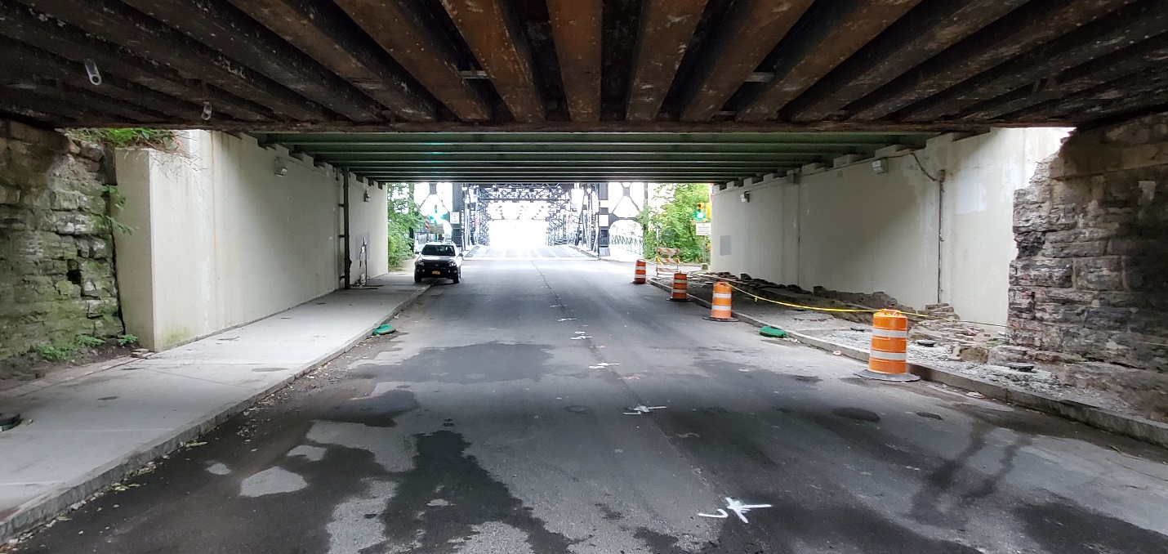
- Art installation/design under 190 overpass
South Side

65’
14’’

10’

Art installation/design under 190 Overpass

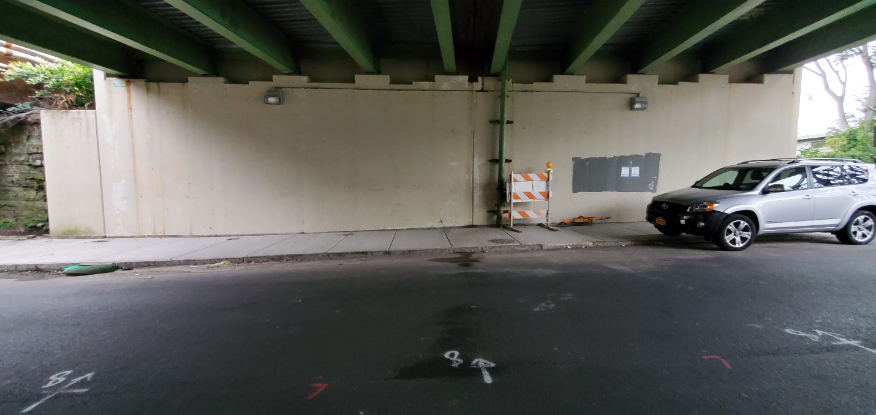

- Art installation/design under 190 Overpass
North Side

14’

65’

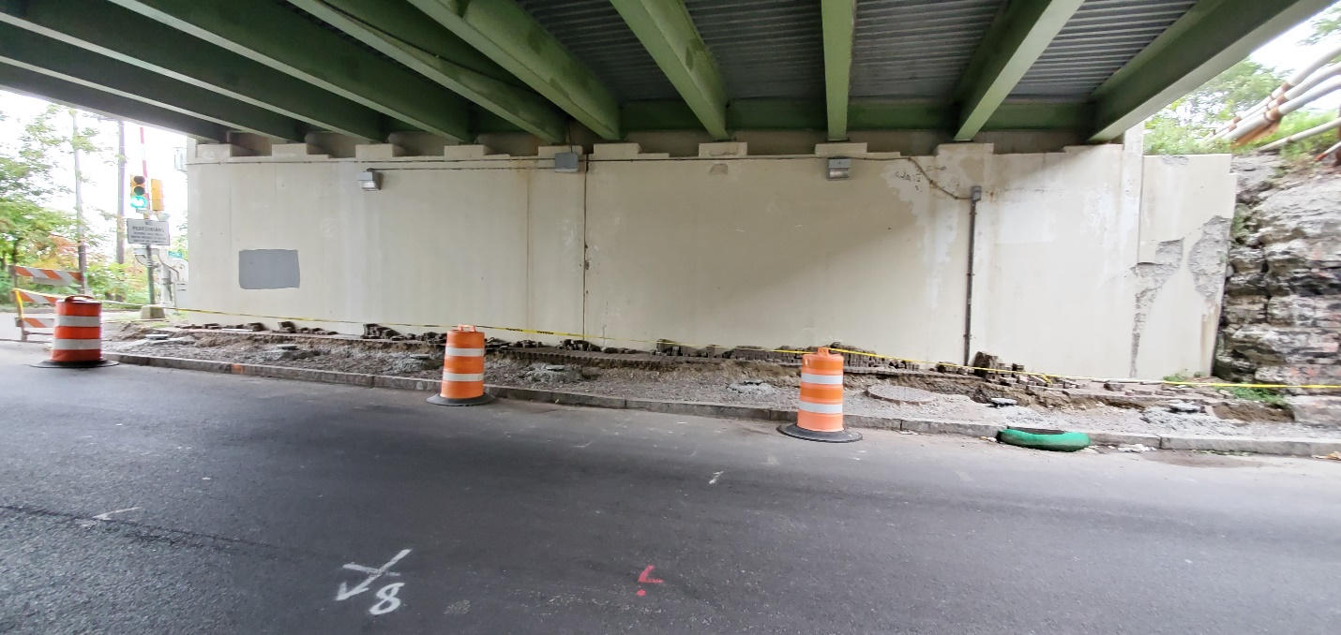

Art installation/design under 190 Overpass
North Side - Auxilary wall facing West ( 20’ High X 28’) Long

